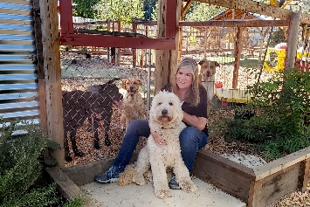

**Stay and Play Dog Care**

**Emergency Contact and Medical Release Form**

Date_______________________________

Emergency Contact and Medical Release Information

Should you be unavailable, list whom would you like us to contact in case of an emergency:

Name____________________________________________________ Phone__________________________

Address__________________________________________________________________________________

I give permission for release of my pet in the event of an emergency to the person named above. I further give permission for medical attention outlined below, including accepting financial responsibility for medical care for my pet. This permission is valid for a 12-month period from the date signed.

I give Donna Blake or her representative permission to seek any and all emergency medical attention deemed necessary for my pet listed above. I further agree to be financially responsible for all veterinary bills incurred on behalf of my pet. This agreement is valid for a 12-month period from the date signed. Please Note: if medical care is required, we will attempt to phone you and allow you to make medical decisions regarding your animal. If you are unavailable, we will make decisions based on the best interest of your animal. If there is a maximum amount you would authorize on veterinary care, please identify that here: $___________

I have read the Stay and Play Dog Care policies and medical release information. I agree to all of the above information.

_________________________________________________ ______________________________________

Signature Date